**Install a LAMP Web Server on Amazon Linux 2**

Time spent: 60 min

What I learned:

* How to install LAMP server on the instance
* How to set file permissions to allow the ec2-user account to manipulate files in this directory

What I built:

* Start an instance and install the LAMP server

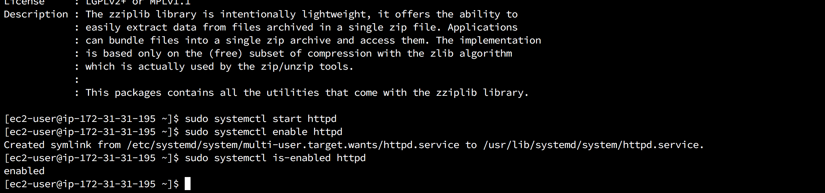

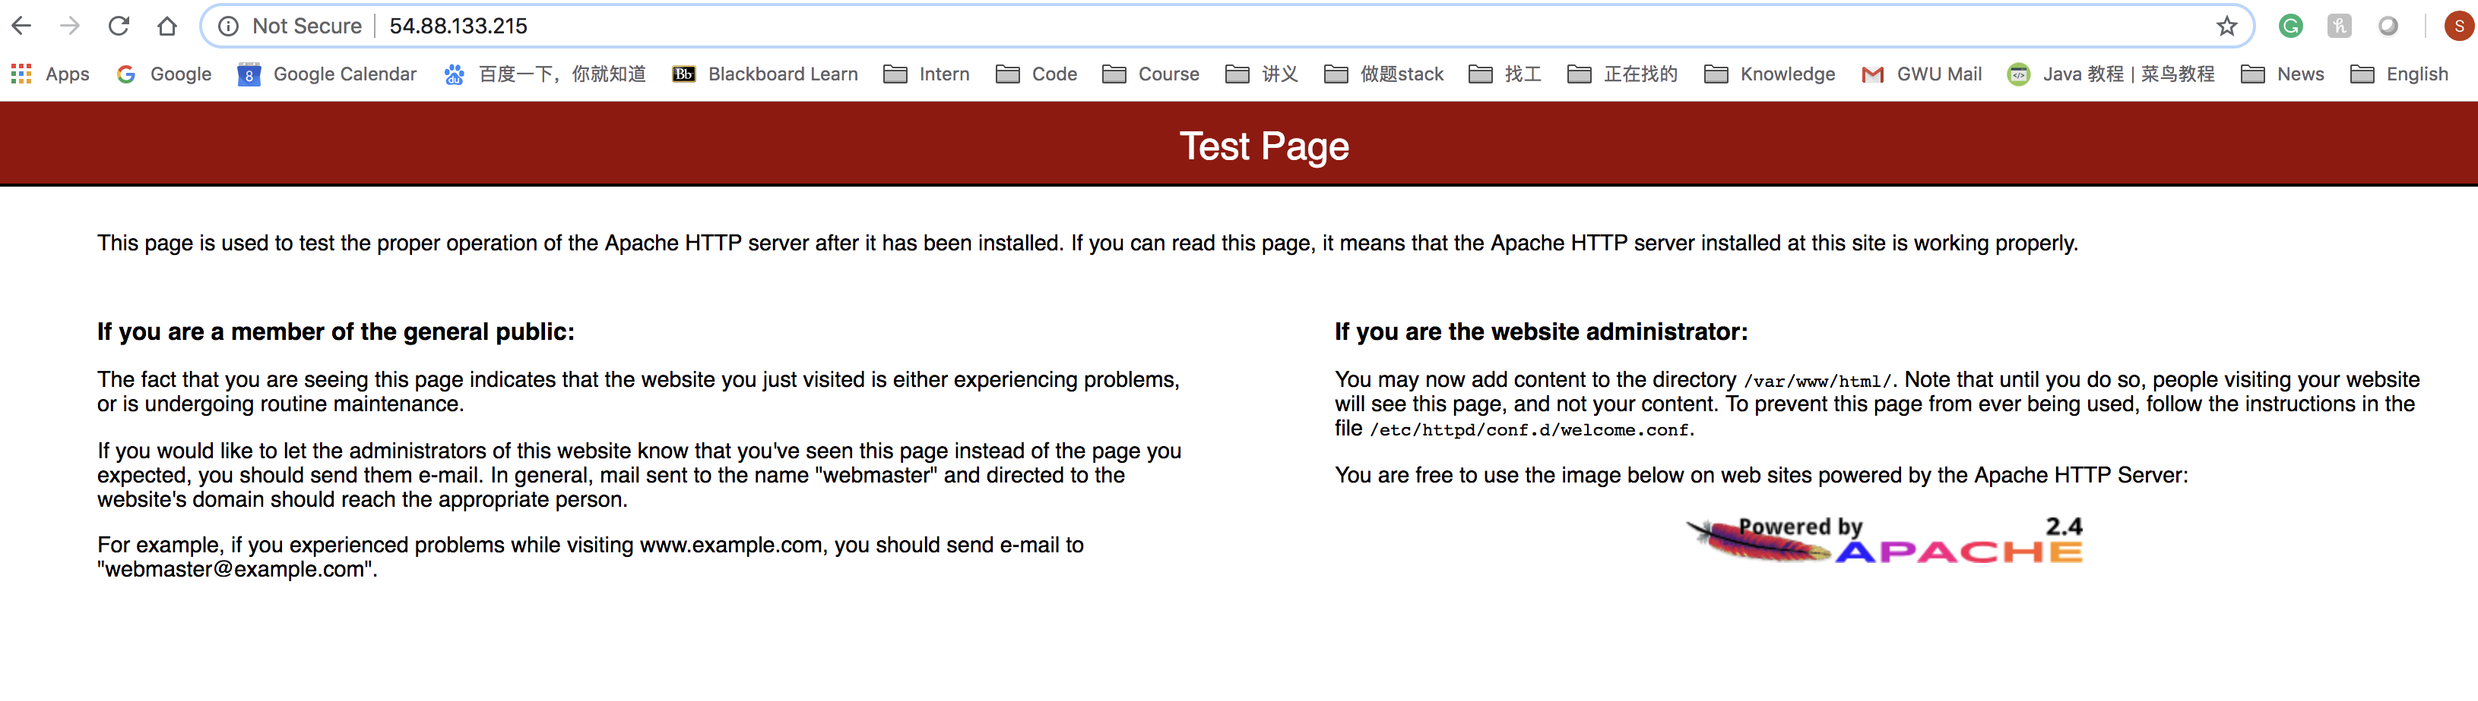

* Test the LAMP server

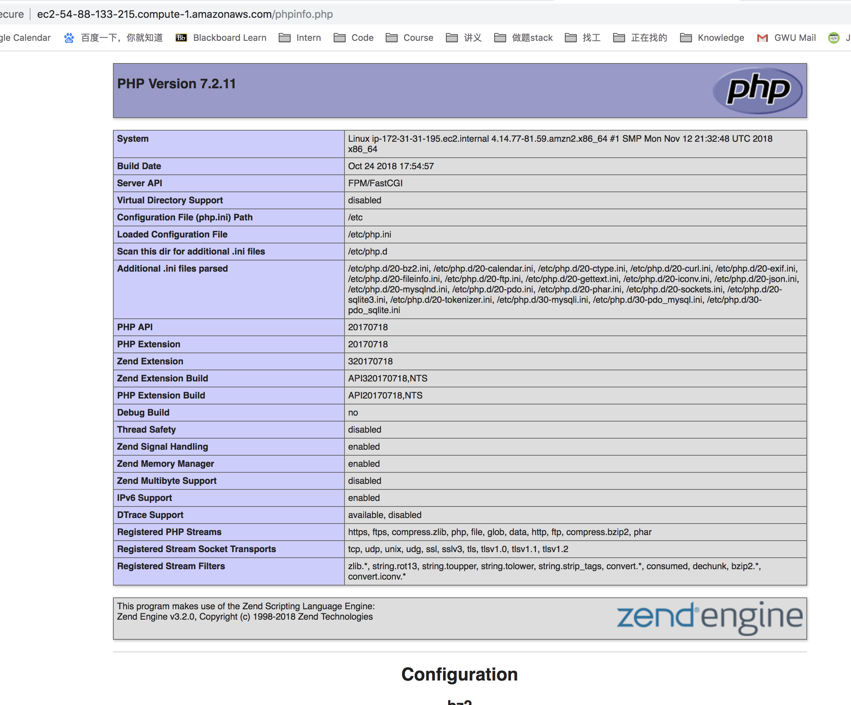

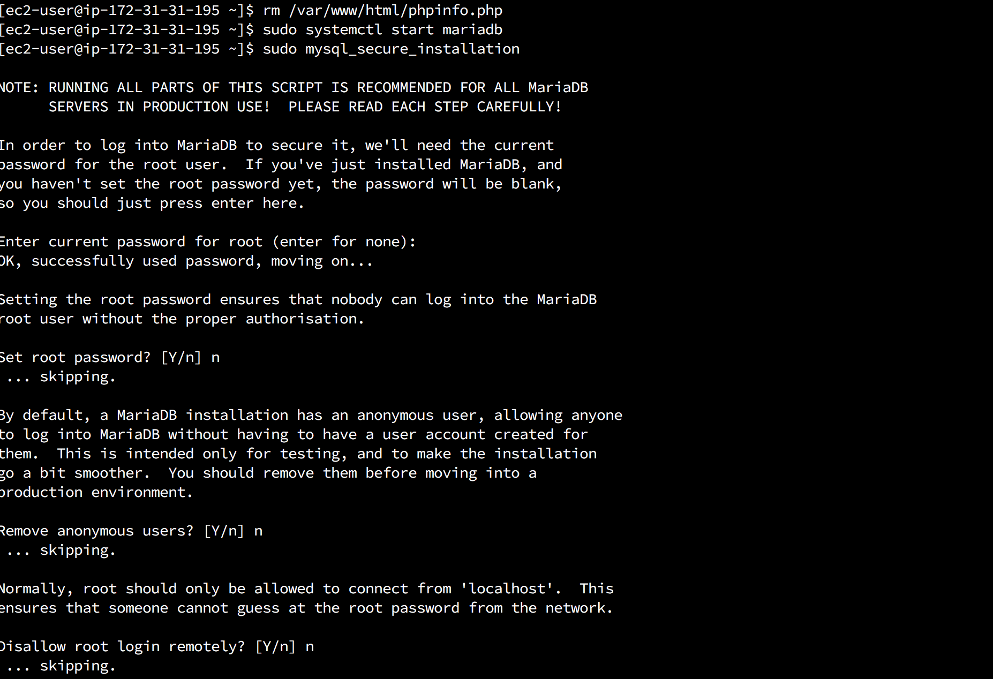

Summary:

In this section, I successfully built Web Server on the Amazon EC2.